

Aquatics Update for Fall 2026

Our aquatics facilities are getting ready to shift to a fall schedule. Central Pool will close for the season on Monday, August 17. Beginning that same day, lap swim and open swim will move to Centennial Aquatic Center under modified "Back to School" hours. The Centennial Splash Pad will also open free to the public from 9:00am to 8:00pm, weather permitting.
Why We Are Making This Change
Several factors led to this decision. Many of our lifeguards are students, which makes it difficult to staff two pools once school is back in session, and attendance at both pools historically drops during that same period. Consolidating our aquatics operations to Centennial Aquatic Facility allows us to be good stewards of our resources, including the chemicals and maintenance that both the pool and splash pad require. This allows for operational efficiency, which helps keep at least one pool open as long as possible.
Ongoing Communication
This change has been a part of ongoing discussions since November 2025 and has been communicated to residents throughout the year, including in the Winter, Spring, and Summer program guides, on the website, and on this year's membership registration forms.
Important Membership Note
Please be advised that beginning Monday, August 17, 2026, open swim and lap swim sessions will be held at Centennial Aquatic Center. This change ensures that you can continue to enjoy these programs in a safe and well-equipped facility.
Please note that amenities at Centennial, including baby pool, slides, and diving well, will open based on lifeguard availability.
- Centennial Aquatic Center: Back to School Hours (Starting August 17)
- Splash Pad: 9:00am to 8:00pm, free to the public (weather permitting)

- Centennial Pool:
Day | Lap Swim | Open Swim
Monday | 7:30am to 9:30am | —
Tuesday | 7:00am to 9:00am and 5:00pm to 7:00pm | —
Wednesday | 7:30am to 9:30am | —
Thursday | 7:00am to 9:00am and 5:00pm to 7:00pm | —
Friday | 7:00am to 9:00am | 4:00pm to 7:30pm
Saturday | 9:00am to 12:00pm | 12:30pm to 5:30pm
Sunday | 9:00am to 12:00pm | 12:30pm to 5:30pm
Labor Day Hours (Last Day of the Season)
Monday, September 7: Open Swim, 11:00am to 5:00pm

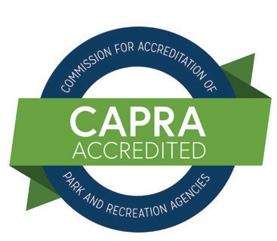


BOARD OF COMMISSIONERS

Ryan Donahue | Melissa Mottl | Melinda Stalker | Jim Buschbach Jr. | Andrea Zumhagen

